Final Report
Jianyu Shen
JIS77@pitt.edu
Two retina images (fundus images) are given as attached, each is in color and of 3900 x3072 pixels. The yellow bright circular spot is the optical disk. Centered around the optical disk, crop out 1024 x 1024 pixels, and take the green channel for study.
(1)Use whatever method that you choose to segment out the optical disk and main vessels as much as possible in each image.
In this project, I will use the texture segmentation to segment the disk and vessels from the original figure.

First Step: Crop out the 1024*1024 pixels form the original image.
I haved used this two mainly code to achieve crop out the 1024*1024 figure.
(1) Imcrop() ------- clipping figure
(2) rgb2gray() ------- gray level image
Second Step: Begin the texture segmentation
(1)Use entropyfilt to create a texture image.
Entropy is a statistical measure of randomness,it returns an array where each output pixel contains the entropy value of the 9-by-9 neighborhood around the corresponding pixel in the input image I.
The following figure is the two original gray figures after applied the step 1 method.

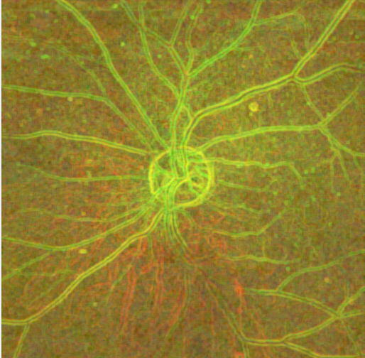

(2)Create Rough Mask for the Bottom Texture
After applied this method on that,we can find that the texture method is not a good used method to segment the bottom texture.
(3)Use Rough Mask to Segment the Top Texture
After applied this method to top textreu we can find that this method is good used to fing the disk and vessel in the image.
(4)Display Segmentation Results.Use mask2 to extract the top and bottom texture from image.
The matlab code is expressed as below:

After applied crop method to two figure we can see that the output of 1024*1024 figure is displayed as below :

The outcome figure after I applied the texture sengemntation is displayed as below:

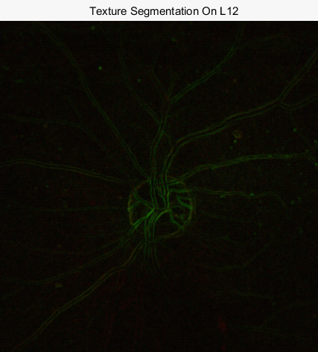
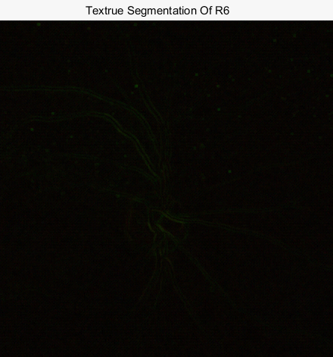

We can see that after apply the texture segmentation to this two figure,the disk and vessel have been successfully pick out.
While compare this two outcome figure,the first figure is more clear than second one.This may beccause the energy of two initial figiures are different.

(2)Evaluate statistical texture in each image (choose texture features that you like to study) by use of either Gabor method or Laws texture energy method, can you say any difference in textures between these two image.
I will use Gabor method to this figure to find statistical feathers.And the following figures are the Matlab code:

The following figrue is the output figure after applied Gabor method to it:
The left one is figure L12 ,the right one is figure R6.Both of them were applied Gabor method.

From these two figures we can see that the left one are more clear than right one, so maybe the energy of left figure is more than right figure.
Overall,the statistcial feathers are almost the same in the right figure and left figrue.

